LAB 3 – Raja Aadhithan
Design – 4x1 mux using behavioral:
Wave:
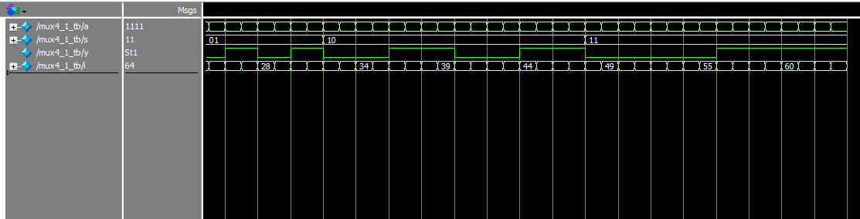
Output:
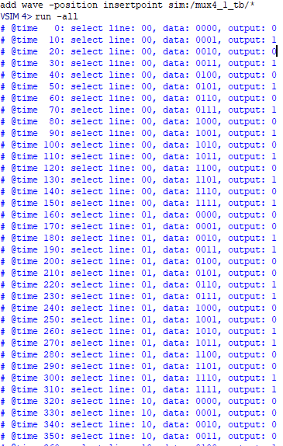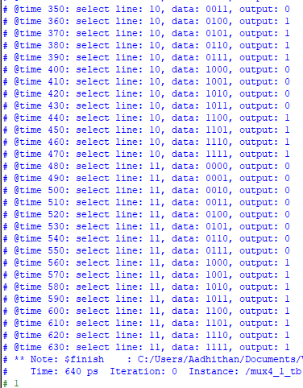

RTL:
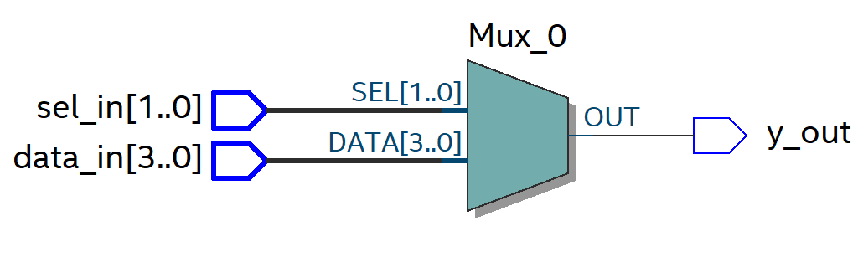

Design: 3:8 Decoder:
Wave
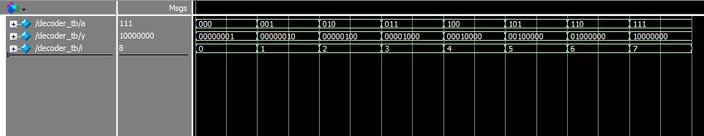
Output :
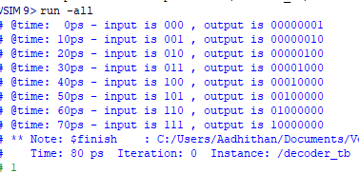

RTL:
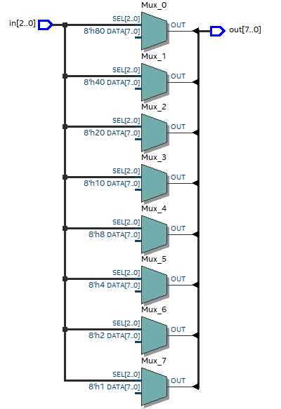
Design: 8:3 priority encoder:
Wave:
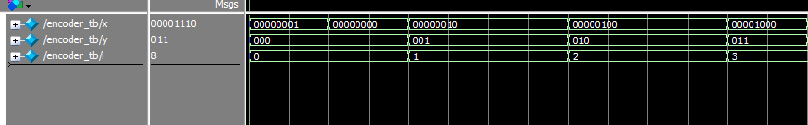
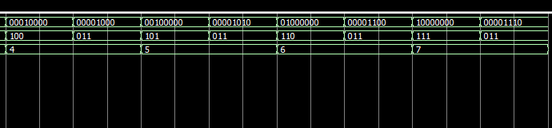
Output:
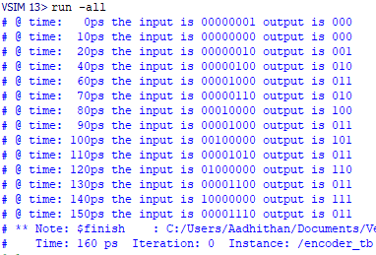
RTL :
